**INTERNSHIP PROJECT REPORT ON:**

**HEALTH MONITORING & MANAGEMENT USING IoT**

**SENSING WITH CLOUD BASE PROCESSING**



**Submitted By :**

**Student Name : Rohini Kamble (3GN14EC024)**

**Akash Gaikwad (3GN16EC021)**

**Divyani ( 3GN18EC400 )**

**UNDERTAKING**

I declare that the work presented in this project titled **“HEALTH MONITORING & MANAGEMENT USING IoT SENSING WITH CLOUD BASE PROCESSING**”, submitted to the All India council of robotics and Automation, for the award of the Internship in **INTERNET OF THINGS**, is my original work. I have not plagiarized or submitted the same work for the award of any other Internship. In case this undertaking is found incorrect, I accept that my Project may be unconditionally withdrawn.

October,2021

**Rohini Kamble (3GN14EC024)**

**Akash Gaikwad (3GN16EC021)**

**Divyani ( 3GN18EC400 )**

**CERTIFICATE**

Certified that the work contained in the project titled **“HEALTH MONITORING & MANAGEMENT USING IoT SENSING WITH CLOUD BASE PROCESSING**”by **Rohini Kamble, Akash Gaikwad & Divyani**

has been carried out under my supervision and that this work has not been submitted elsewhere for an internship.

All India Council of Robotics and Automation

Internet Of Things

Delhi-110020

**Acknowledgements**

I take upon this opportunity to acknowledge the many people whose prayers and support meant a lot to me.

I am deeply indebted to **Sumit Chatterjee, Research Engineer** and **ALAAUDEEN K M**, **trainer** who motivated me along the way.

I would like to thank all my teachers who help me in this project.

I further thank my friends.

My heartfelt thanks to parents who supported me a lot.

I owe my sincere gratitude towards the God.

Finally, I would like to wind up by paying my heartfelt thanks to AICRA institute who provided me with this great opportunity.

**Rohini Kamble**

**Akash Gaikwad**

**Divyani**

**Contents :**

* **Introduction**
* **Assistive Techonology**
* **System Design**
* **Literature Survey**
* **Block Diagram**
* **Requirements**
* **Hardware Requirements**
* **Arduino Uno**
* **Technical Specification**
* **ESP32-Camera**
* **Ultrasonic Sensor**
* **Software Specification**
* **Arduino IDE**
* **Embeded C**
* **HTML**
* **Methodology**
* **Circuit Connection**
* **Experimental Setup & Working**
* **Result**
* **Advantagaes & Disadvantages**
* **Applications**
* **Conclusion**
* **Reference**

**CHAPTER - 1**

**INTRODUCTION**

Visual Information is inaccessible for individuals who are blind or visually impaired, as it is a purely visual feature. Given that many everyday tasks rely on visual data including coordinating person, social interactions, etc., the inaccessibility of vision has an adverse effect on daily life. We propose an interactive, wearable assistive device that can recognize and convey meaningful data and guidance. As computer vision is challenging in real world environments due to, e.g., illumination or pose changes, computer vision algorithms can be augmented with subsystems that can provide information on working environments of a recognition algorithm, and how it affects the recognition accuracy. Current products made to help the blind navigate rely heavily on GPS, which isn’t always detailed or accurate enough to distinguish between, say, a sidewalk and a street. Plus, GPS isn’t always available in places like parking garages, underground transit stations and sports venues, and it doesn’t pick up on obstacles like crowds and cars.

Visual impairment afflicts approximately 285 million people worldwide according to recent estimates by the World Health Organization (WHO) and, without additional interventions, these numbers are predicted to increase significantly. One of the many challenges faced by this population is their inability to recognize the faces of known individuals when they encounter them in their daily lives. One consequence of this is that whenever a visually impaired individual arrives in a social setting (e.g., in a conference room or at a dinner party), the conversation has to be interrupted to announce which people are already present on the scene which may result in some social awkwardness. The importance of being able to view faces in social interactions is also confirmed by several studies which indicate that most of our communication takes place not through words but via non-verbal means, the majority of which consist of facial expressions. Furthermore, the ability to determine if an approaching person is a friend or a stranger is essential from a security perspective and also contributes to a person’s general awareness of his context and surroundings.

The exponential increase in computing power per volume coupled with the decreasing size of computing elements and sensors in recent years has opened up the possibility of running computationally demanding applications on wearable electronic devices. These advances, in conjunction with the needs specified above, have fueled research into developing wearable face recognition aids for the visually impaired in the past few years. This area of research is still in its infancy with only a few prototype systems being implemented for this purpose so far. These solutions are characterized by their emphasis on portability, convenience, intuitiveness, and cost-effectiveness. The objective of this paper is to provide an overview of the state of the art in this domain, highlighting the strengths and weaknesses of different solutions, to discuss some of the issues that need to be addressed and resolved to expedite the practical deployment and widespread acceptance of such systems, and to facilitate and inspire further research in this realm.

**1.1 Assistive Technology**

From the point of view of visually impaired people the perception of the surrounding environment is very important, even essential, in order to facilitate their mobility. Assistive technologies for environmental perception and for navigation in the surrounding environment are advancing day by day. In the last decade a variety of portable navigation systems have been designed to assist people with visual disabilities during navigation in the indoor/outdoor known/unknown environments.

**1.2 System Design**

* Input interface layer: Connect the input devices in this section.
* Processing layer: The Arduino Uno is a microcontroller board based on the ATmega328 (datasheet). It has 14 digital input/output pins, 6 analog inputs, a 16 MHz ceramic resonator, a USB connection, a power jack, an ICSP header, and a reset button. It contains everything needed to support the microcontroller; simply connect it to a computer with a USB cable or power it with a AC-to-DC adapter or battery to get started.

**Chapter 2**

**LITERATURE SURVEY**

**Krishna** have developed the iCare Interaction Assistant, an assistive system that acquires video from a pinhole aperture analogy CCD camera embedded in a pair of eyeglasses, digitizes it and then transmits it over a USB cable to a tablet PC. The video is analyzed to detect faces using adaptive boosting which are passed to a face recognition module that utilizes the Principal Components Analysis (PCA) and Linear Discrimination Analysis (LDA) algorithms. If a face is recognized in 5 consecutive frames, the name of the identified individual is converted from text to speech and transmitted to the user via head phones. One main concern expressed by Krishna is that even though some publicly available face databases contain images captured under a range of poses and illumination angles, however, none of them use a precisely calibrated mechanism for acquiring these images, nor is each image explicitly annotated with this information. Krishna et al. have therefore, put together their own database called Face Pic which contains face images of 30 people with pose angles and illumination angles between -90 and +90 degrees annotated in 1 -degree increments. An empirical evaluation of four of the most widely used face recognition algorithms – PCA , LDA, BIC (Bayesian Interpersonal Classifier) and HMM (Hidden Markov Model) – on this database showed the two subspace methods (i.e., PCA and LDA) to be the best performing ones with respect to both pose and illumination angle variance. These two methods were, therefore, selected for the face recognition module of the system. The system was tested with 10 known individuals and PCA’s performance was found to be better than (or similar to) LDA. Since PCA’s computational complexity is also lower than that of LDA, hence it is the preferred algorithm for future development work on this device.

**Balduzzi** have developed a prototype for a compact PC that acquires a video stream from a small form video camera and analyzes it to detect human faces in the scene (by detecting skin-colored regions and finding faces among them using a cascade of Support Vector Machine (SVM) classifiers; eye and nose detection is then applied to the face regions to select the faces in which these features are unconcluded). The face recognition module, which is based on Local Binary Patterns (LBP), attempts to recognize the detected faces. To avoid audio spamming, this module aggregates the results over N consecutive frames and provides feedback only if the last N frames have provided some concrete results. If the person is identified or an unknown person is detected, in either case, an audio feedback is provided to the user via a speaker set. LBP descriptions were selected based on some initial tests that demonstrated their superiority over Local Ternary Patterns and Histogram of Gradient. The system was found to be robust to viewpoint changes of up to 30 degrees. Interviews conducted with prospective users of this prototype revealed that though most people were satisfied with the face detection and feedback speeds, however, the I/O interface and the face recognition capabilities need to be substantially improved to meet the users’ expectations.

**Kramer**  have implemented a client application for a smart phone that acquires images using the phone’s built-in camera, wirelessly transmits them to a remote server for identification, receives the recognition results and then transmits them to the user via the phone’s speech interface. The server application utilizes Overlook, a commercially available face recognition package, with the ability to detect and recognize multiple faces per frame. To determine the robustness of the Overlook technology to changes in viewpoint, images of 10 subjects were taken from 15 different positions with different head orientations. To make the test more realistic, images of 78 additional people were also downloaded from the CalTech and GeorgiaTech face databases and added to the database of known faces. Experiments showed that Overlook could tolerate up to 40o and 20o changes in viewpoint and head tilt angles, respectively. The system has been reported to have high recognition accuracy based on initial tests conducted with 10 known users.

**F. Battaglia** developed Blind Assistant is a software platform that integrates many different functionalities for the visually impaired, namely, face recognition, text recognition (restricted to labels and short sentences), place recognition, e-mail (reading and dictating), colour recognition and barcode reading. We will focus our discussion on the face recognition module of this system. This solution utilizes the Nano-desktop, a freely available, open-source software aimed at developing computer vision applications on embedded systems. The system consists of a handheld console equipped with a pair of RISC microprocessors, a video accelerator, a wireless connection, a USB port and a slot for flash memory cards. A webcam connected to the console is used to acquire images of the scene in front of the user. The images are normalized with respect to luminosity, the faces within them are detected using the Viola-Jones algorithm and recognition is performed based on the PCA algorithm. If a person is recognized, a spoken message relays his identity and average position to the user. The system was tested with 15 visually impaired users and though the PCA algorithm featured an accuracy of only around 80%, but the face recognition part was still rated as reliable and interesting by most users. The most attractive aspect of their system is that it is an open source platform running on widely available hardware and is, thus, accessible to the largest community of users and developers.

**Astler** have proposed to develop a device that will communicate the names of familiar conversation partners, as well as their expression states, differentiated as six universal macro-expressions (i.e. happiness, sadness, disgust, surprise, fear, and anger) to facilitate social interaction for the visually impaired. A pair of stereovision cameras mounted either on the forehead or embedded in sunglasses, to better emulate human vision, would be used to acquire image data which will then be transmitted to a Microsoft Windows capable laptop computer (which the user can carry in a backpack) via a USB connection. Face recognition based on the PCA-SIFT algorithm and expression analysis based on a parametric flow model will be performed and the results will be conveyed to the user via a voice recognition and an audio feedback system with text-to-speech capabilities as well as a hectic feedback belt. The user interface will be built upon the framework already developed by Caperna. Astlerplan to conduct interviews with visually impaired users individually as well as in focus groups and intend to incorporate their feedback into the product design. They also plan to survey a group of sighted subjects in order to better understand how society may view users of their technology. The system will first be tested for accuracy and efficiency with facial images from the Cohn-Kanade Database using a method similar to Krishna before being tested with the target population.

**CHAPTER – 3**

**BLOCK DIAGRAM**

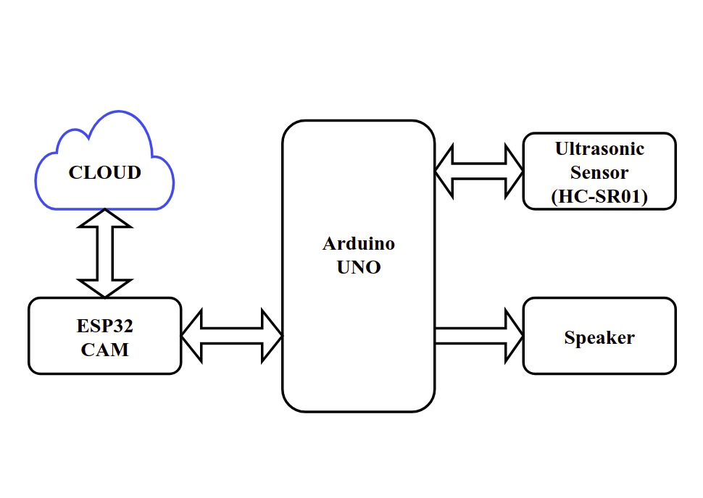

**Fig 3.1 Block Diagram for the System**

**CHAPTER - 4**

**REQUIREMENTS**

**4.1 Hardware Requirements**

**4.1.1 Arduino Uno**

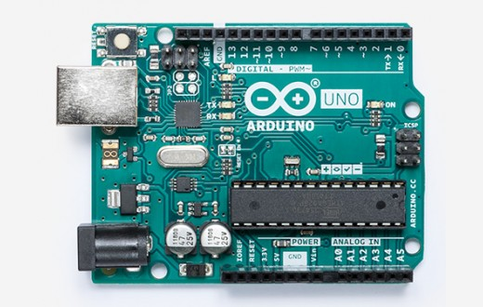

**Fig. 4.1.1: Arduino Uno**

Arduino is an open source computer hardware and software company, project, and user community that designs and manufactures single-board microcontrollers and microcontroller kits for building digital devices and interactive objects that can sense and control objects in the physical world. Arduino board designs use a variety of microprocessors and controllers. The boards feature serial communications interfaces, including Universal Serial Bus (USB) on some models, which are also used for loading programs from personal computers.

**TECHNICAL SPECIFICATION:**

|  |  |
| --- | --- |
| Microcontroller | [ATmega328P](https://components101.com/microcontrollers/atmega328p-pinout-features-datasheet) 8-bit AVR family |
| Operating Voltage | 5V |
| Recommended Input Voltage | 7-12V |
| Input Voltage Limits | 6-20V |
| Analog Input Pins | 6 (A0 – A5) |
| Digital I/O Pins | 14 (Out of which 6 provide PWM output) |
| DC Current on I/O Pins | 40 MA |
| DC Current on 3.3V Pin | 50 Ma |
| Flash Memory | 32 KB (0.5 KB is used for Boot loader) |
| SRAM | 2 KB |
| EEPROM | 1 KB |
| Frequency (Clock Speed) | 16 MHz |

**TABLE 4.1.1.1: Technical Specification of Arduino Uno**

**Pin Description :**

|  |  |  |
| --- | --- | --- |
| Pin Category | Pin Name | Details |
| Power | Vin, 3.3V, 5V, GND | Vin: Input voltage to Arduino.  5V: Regulated power supply used to power microcontroller and other components on the board.  3.3V: 3.3V supply generated by on-board voltage regulator. Maximum current draw is 50mA.  GND: ground pins. |
| Reset | Reset | Resets the microcontroller. |
| Analog Pins | A0 – A5 | Used to provide analog input (0-5V) |
| Input/output | Digital Pins 0 - 13 | Can be used as input or output pins. |
| Serial | 0(Rx), 1(Tx) | Used to receive and transmit TTL serial data. |
| External Interrupts | 2, 3 | To trigger an interrupt. |
| PWM | 3, 5, 6, 9, 11 | Provides 8-bit PWM output. |
| SPI | 10(SS), 11(MOSI),  12(MISO) and13(SCK) | Used for SPI communication. |
| Inbuilt LED | 13 | To turn on the inbuilt LED. |
| TWI | A4 (SDA), A5(SCA) | Used for TWI communication. |
| AREF | AREF | To provide reference voltage for input voltage. |

**Table 4.1.1.2: Pin Description of Arduino Uno**

**4.1.2 ESP32-Camera**



**Fig 4.1.2:’ ESP32-Camera**

ESP32-CAM is a low-cost ESP32-based development board with onboard camera, small in size. It is an ideal solution for IoT application, prototypes constructions and DIY projects. The board integrates WiFi, traditional Bluetooth and low power BLE, with 2 high performance 32-bit LX6 CPUs.

It adopts 7-stage pipeline architecture, on-chip sensor, Hall sensor, temperature sensor and so on, and its main frequency adjustment ranges from 80MHz to 240MHz. Fully compliant with WiFi 802.11b/g/n/e/i and Bluetooth 4.2 standards, it can be used as a master mode to build an independent network controller, or as a slave to other host MCUs to add networking capabilities to existing devices ESP32-CAM can be widely used in various IoT applications.

It is suitable for home smart devices, industrial wireless control, wireless monitoring, QR wireless identification, wireless positioning system signals and other IoT applications. It is an ideal solution for IoT applications.

**Features:**

* Up to 160MHz clock speed, Summary computing power up to 600 DMIPS
* Built-in 520 KB SRAM, external 4MPSRAM
* Supports UART/SPI/I2C/PWM/ADC/DAC
* Support OV2640 and OV7670 cameras, Built-in Flash lamp.
* Support image WiFI upload
* Support TF card
* Supports multiple sleep modes.
* Embedded Lwip and FreeRTOS
* Supports STA/AP/STA+AP operation mode
* Support Smart Config/AirKiss technology
* Support for serial port local and remote firmware upgrades (FOTA)

**SPECIFICATION:**

* SPI Flash: default 32Mbit
* RAM: built-in 520 KB+external 4MPSRAM
* Dimension: 27*40.5*4.5（±0.2）mm/1.06*1.59*0.18”
* Bluetooth: Bluetooth 4.2 BR/EDR and BLE standards
* Wi-Fi: 802.11b/g/n/e/i
* Support Interface: UART, SPI, I2C, PWM
* Support TF card: maximum support 4G
* IO port: 9
* Serial Port Baud-rate: Default 115200 bps
* Image Output Format: JPEG( OV2640 support only ), BMP, GRAYSCALE
* Spectrum Range: 2412 ~2484MHz
* Antenna: onboard PCB antenna, gain 2dBi
* Transmit Power:
  + 802.11b: 17±2 dBm (@11Mbps);
  + 802.11g: 14±2 dBm (@54Mbps);
  + 802.11n: 13±2 dBm (@MCS7)

**4.1.3 Ultrasonic Sensor (HC-SR04)**

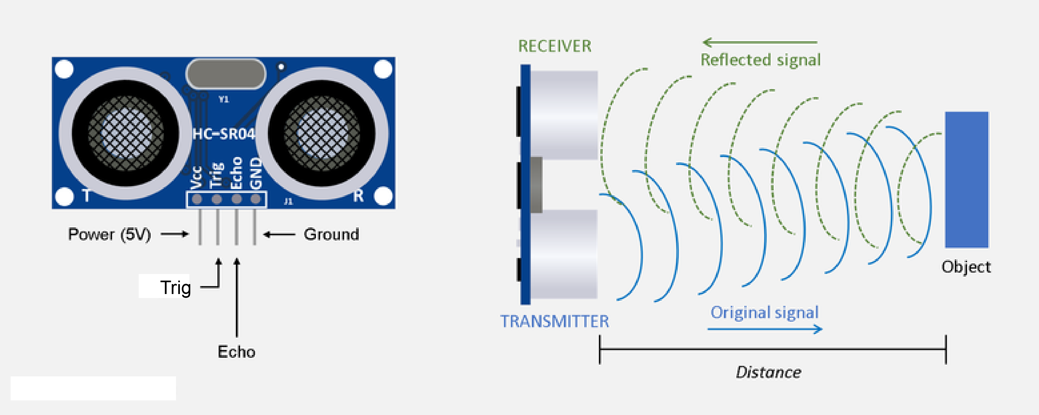

A

S Shown above the HC-SR04 Ultrasonic (US) sensor is a 4 pin module, whose pin names are Vcc, Trigger, Echo and Ground respectively. This sensor is a very popular sensor used in many applications where measuring distance or sensing objects are required. The module has two eyes like projects in the front which forms the Ultrasonic transmitter and Receiver. The sensor works with the simple high school formula that Distance = Speed × Time.

The Ultrasonic transmitter transmits an ultrasonic wave, this wave travels in air and when it gets objected by any material it gets refted back toward the sensor this reflected wave is observed by the Ultrasonic receiver module as shown in the picture above.

The working principle of this module is simple.  It sends an ultrasonic pulse out at 40kHz which travels through the air and if there is an obstacle or object, it will bounce back to the sensor.  By calculating the travel time and the speed of sound, the distance can be calculated.

Ultrasonic sensors are a great solution for the detection of clear objects.  For liquid level measurement, applications that use infrared sensors, for instance, struggle with this particular use case because of target translucence.

For presence detection, ultrasonic sensors detect objects regardless of the color, surface, or material (unless the material is very soft like wool, as it would absorb sound.)

To detect transparent and other items where optical technologies may fail, ultrasonic sensors are a reliable choice.

Now, to calculate the distance using the above formulae, we should know the Speed and time. Since we are using the Ultrasonic wave we know the universal speed of US wave at room conditions which is 330m/s. The circuitry inbuilt on the module will calculate the time taken for the US wave to come back and turns on the echo pin high for that same particular amount of time, this way we can also know the time taken. Now simply calculate the distance using a microcontroller or microprocessor.

**Features:**

* Operating voltage: +5V
* Theoretical  Measuring Distance: 2cm to 450cm
* Practical Measuring Distance: 2cm to 80cm
* Accuracy: 3mm
* Measuring angle covered: <15°
* Operating Current: <15mA
* Operating Frequency: 40Hz

**4.2 Software Specification**

**4.2.1Arduino IDE**

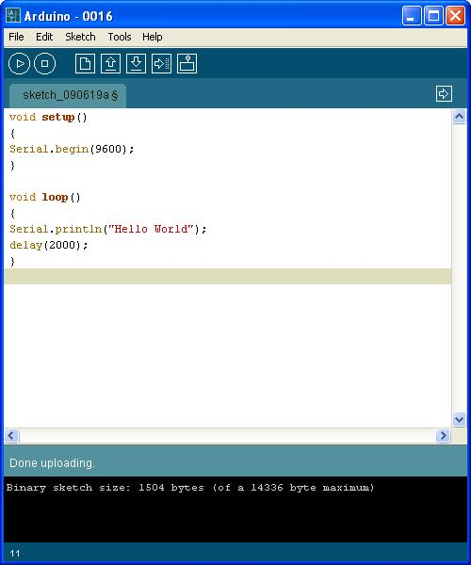

**Fig. 4.2.1: Arduino IDE**

Arduino is an open-source project, enabling hobbyists to easily take advantage of the powerful Atmega chips. The Arduino IDE is the software where you can write code and upload it to the Atmega chip.

The code is then executed on the chip. Most 3D-printer electronics are Arduino-compatible, they use the Atmega chip and enable the user to upload their code using Arduino. This includes Megatronics, Minitronics and RAMPS.

Before you can start using the electronics you need software ‘firmware’ that translates machine instructions into actual movements.

There are a few options here, including Marlin and Sprinter and Repeater. The actual firmware is not discussed in this document. You can use Arduino to upload this firmware onto your electronics.

[P[[This document will guide you in the steps you need to take.

* Arduino IDE is an open source software that is mainly used for writing and compiling the code into the Arduino Module.
* It is an official Arduino software, making code compilation too easy that even a common person with no prior technical knowledge can get their feet wet with the learning process.
* It is easily available for operating systems like MAC, Windows, Linux and runs on the Java Platform that comes with inbuilt functions and commands that play a vital role for debugging, editing and compiling the code in the environment.
* A range of Arduino modules available including Arduino Uno, Arduino Mega, Arduino Leonardo, [Arduino Micro](https://www.theengineeringprojects.com/2018/09/introduction-to-arduino-micro.html)and many more.
* Each of them contains a microcontroller on the board that is actually programmed and accepts the information in the form of code.
* The main code, also known as a sketch, created on the IDE platform will ultimately generate a Hex File which is then transferred and uploaded in the controller on the board.
* The IDE environment mainly contains two basic parts: Editor and Compiler where former is used for writing the required code and later is used for compiling and uploading the code into the given Arduino Module.
* This environment supports both C and C++ languages.

**4.2.2 Embedded C**

Embedded C is one of the most popular and most commonly used Programming Languages in the development of Embedded Systems. So, in this article, we will see some of the Basics of Embedded C Program and the Programming Structure of Embedded C.

Embedded C is perhaps the most popular languages among Embedded Programmers for programming Embedded Systems. There are many popular programming languages like Assembly, BASIC, C++, Python etc. that are often used for developing Embedded Systems but Embedded C remains popular due to its efficiency, less development time and portability.

Before digging in to the basics of Embedded C Program, we will first take a look at what an Embedded System is and the importance of Programming Language in Embedded Systems.An Embedded System can be best described as a system which has both the hardware and software and is designed to do a specific task. A good example for an Embedded System, which many households have, is a Washing Machine.

We use washing machines almost daily but wouldn’t get the idea that it is an embedded system consisting of a Processor (and other hardware as well) and software.It takes some inputs from the user like wash cycle, type of clothes, extra soaking and rinsing, spin rpm, etc., performs the necessary actions as per the instructions and finishes washing and drying the clothes. If no new instructions are given for the next wash, then the washing machines repeats the same set of tasks as the previous wash.

Embedded Systems can not only be stand-alone devices like Washing Machines but also be a part of a much larger system. An example for this is a Car. A modern day Car has several individual embedded systems that perform their specific tasks with the aim of making a smooth and safe journey.Some of the embedded systems in a Car are Anti-lock Braking System (ABS), Temperature Monitoring System, Automatic Climate Control, Tire Pressure Monitoring System, Engine Oil Level Monitor, etc.

**4.1.3 HTML**

HTML stands for Hypertext Markup Language, and it is the most widely used language to write Web Pages.

* Hypertext refers to the way in which Web pages (HTML documents) are linked together. Thus, the link available on a webpage is called Hypertext.
* As its name suggests, HTML is a Markup Language which means you use HTML to simply "mark-up" a text document with tags that tell a Web browser how to structure it to display.

Originally, HTML was developed with the intent of defining the structure of documents like headings, paragraphs, lists, and so forth to facilitate the sharing of scientific information between researchers.

Now, HTML is being widely used to format web pages with the help of different tags available in HTML language.

## **Basic HTML Document:**

In its simplest form, following is an example of an HTML document −

<!DOCTYPE html>

<html>

<head>

<title>This is document title</title>

</head>

<body>

<h1>This is a heading</h1>

<p>Document content goes here.....</p>

</body>

</html>

**CHAPTER – 5**

**METHODOLOGY**

**5.1 Circuit connections**

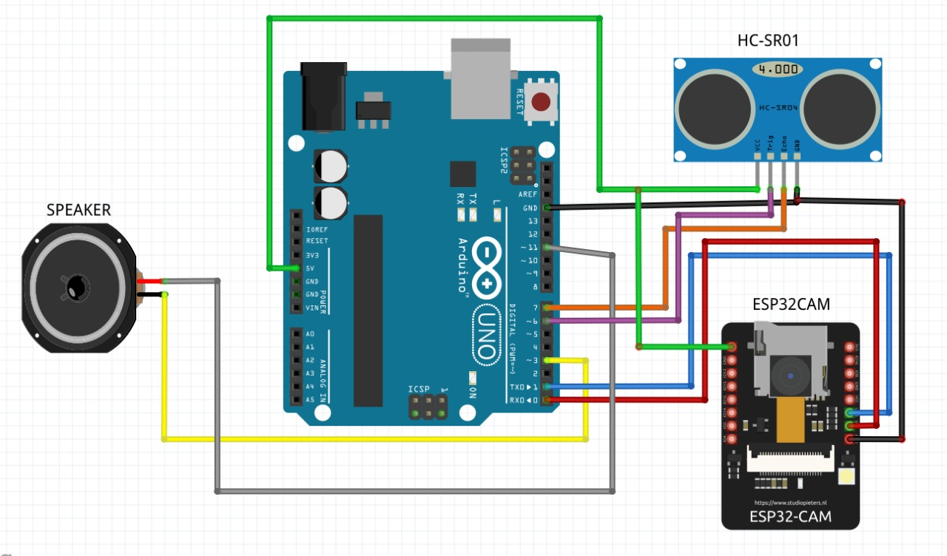

**Fig 5.1.1 Circuit Connections**

Above figure shows the circuit diagram for the system, 5V & GND pins of ESP32-Camera to the 5V & GND of the Arduino UNO respectively. TX & RX of ESP32-Camera is connected to RX & TX of Arduino UNO respectively. VCC, GND, TRIG & ECHO pins of ultrasonic sensors are connected to the 5V, GND, 6 && of Arduino UNO respectively. And one of two end is connected to the pin 11 and other one is connected to pin 3 of Arduino UNO.

**5.2 Experimental Setup and Working**

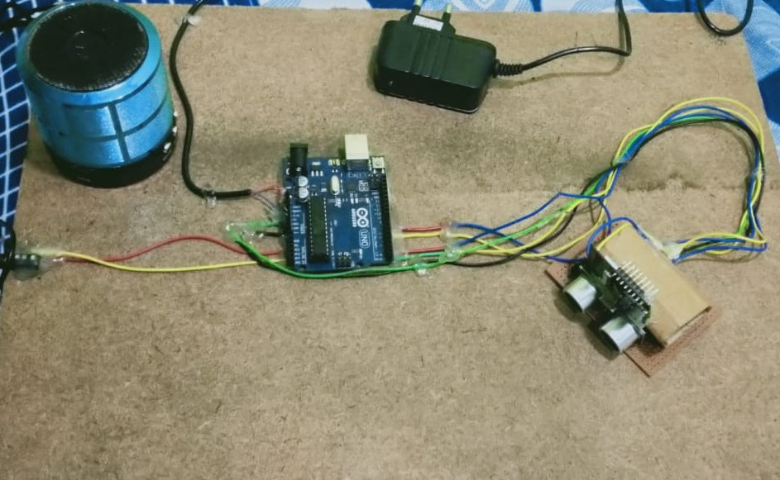

**Fig 5.2.1.1 Experimental setup**

After all the connections are made, threshold value (here 2 Meters) for the ultrasonic sensor to detect any object and Wi-Fi credentials are mentioned in the code and dumped in Arduino UNO and ESP32-Camera respectively. Ultrasonic sensor and camera are aligned in the same direction, so that when ultrasonic sensor detect any object camera sees if it any person or not. Before recognizing the person we should take the sample for the same person.

Total 5 samples of face will be needed for any person to train the algorithm to recognize any face. Hence to enroll we should click enroll button on the website, after that it will take 5 sample and store it in memory (as shown in figure 5.2.1.2). After that we have to assign its name to the taken sample’s ID. Next time when same person shows his face to the camera, the algorithm will recognize him/her and speaks its assigned name into the speaker. If unenrolled person detected by the camera, the speaker will prompt a message to verify the person

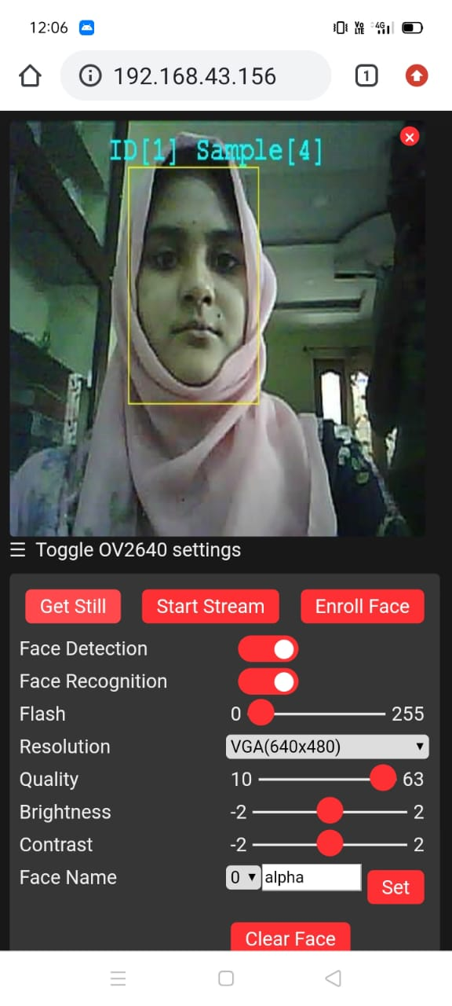

**Fig 5.2.1.2: Snapshot of website taking samples of a face**

**CHAPTER - 6**

**RESULT**

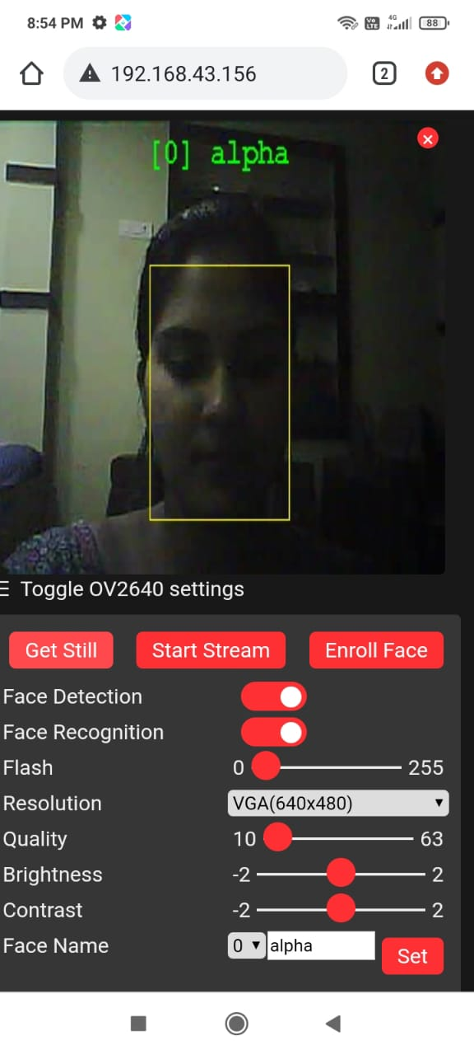

**Fig 6.1: Snapshot of the website of recognition of an enrolled face and prompting a massage as assigned name**

**CHAPTER – 7**

**ADVANTAGES AND DISADVANTAGES**

**7.1 Advantages**

* Systematic exploration of the needs of the individual who are blind or visually impaired
* Works well in laboratory setting
* High resolution face image
* Wide camera coverage area

**7.2 Disadvantages**

* Cannot handle the drastic changes in pose angle or lighting condition.
* The participant’s age, education, background and the level of spoken language for the between group test

**CHAPTER – 8**

**APPLICATIONS**

* Applicable for the individual who are visually impaired in the real world.
* Orientation and mobility
* Employment

**CHAPTER – 9**

**CONCLUSION**

This wearable system that performs image processing based on the ESP32 CAM. The system uses ultrasonic sensors and infrared human body sensors to capture points of interest in the scene, and then uses a micro-camera for specific identification. The recognition of faces, and audio is achieved. The inability to recognize known individuals in the absence of audio or haptic cues severely limits the visually impaired in their social interactions and puts them at risk from a security perspective. An overview of several systems being developed to aid this population in the face recognition task was presented in this system. Though all these systems are still in the prototype stage, however, the initial research, development and testing of these solutions has demonstrated their feasibility and has provided several valuable insights into requirements for assistive devices for this task. Nevertheless, several issues and challenges (which have been highlighted in the previous section) still need to be addressed and resolved to expedite the practical deployment and widespread acceptance of such systems

.

**REFERENCES**

[1] ArandePramila. M, PatilShewta.S“Wireless Temperature detector Systemusing ARDUINO and IOT" International Journal of Computer Trends and Technology.IJCTT-V67I11P113

[2] Ritwik Biswas and Avijit Roy“Real Time Temperature Graph using MATLAB and Arduino”. IJERT-V9IS050482.

[3] D. Oran, E. Topol, Prevalence of Asymptomatic SARS-CoV-2 Infection: A Narrative Review, Annals of Internal Medicine, June 2020, pp. 1-7, 2020.

[4] T. Dbouk, D. Drikakis, “On respiratory droplets and face masks”, Physics of Fluids 32, 063303, pp. 1-11, 2020

[5] P. Zhai,“The epidemiology, diagnosis and treatment ofCOVID19”, International Journal of Antimicrobial Agents vol. 55 issue 5, May 2020, 105955, pp. 1-13, 2020.

[6] P. Dawson, “Loss of Taste and Smell as Distinguishing Symptoms of COVID-19”, Clinical Infectious Diseases June 2020, pp. 1-4, 2020.

[7]L. Morawska, “How can airborne transmission of COVID-19 indoors be minimized?”, Environment International vol. 142, September 2020, 105832, pp. 1-7, 2020.

[8] T. Galbadage, B. Peterson, R. Gunasekera, “Does COVID-19 Spread Through Droplets Alone?”, vol. 8, April 2020, pp. 1-4, 2020.

[9] Y. Song et al., “COVID-19 Treatment: Close to a Cure? – A Rapid Review of Pharmacotherapies for the Novel Coronavirus” [preprint], pp. 1-25, 2020.

[10] V. Balachandar et al., “COVID-19: emerging protective measures”, European Review for Medical and Pharmacological Sciences vol. 24 (6), pp. 3422-3425, 2020.

[11] K. W. Bowyer, K. Chang, and P. J. Flynn, "A survey of approaches and challenges in 3D and multi-modal 3D+2D face recognition," Computer Vision And Image Understanding, vol. 101, pp. 1-15, 2006.

[12] S. G. Kong, J. Heo, B. R. Abidi, J. Paik, and M. A. Abidi, "Recent advances in visual and infrared face recognition - a review," Computer Vision And Image Understanding, vol. 97, pp. 103-135, Jan 2005.

[13] R. Manduchi and J. Coughlan, "(Computer) vision without sight," Commun. ACM, vol. 55, pp. 96-104, 2012.

[14] V. Pradeep, G. Medioni, and J. Weiland, "Robot vision for the visually impaired," in Proc. Workshop on Applications of Computer Vision for the Visually Impaired, San Francisco, CA, 2010, pp. 15-22.

[15] J. Saez and F. Escolano, "Stereo-based aerial obstacle detection for the visually impaired," in Proc. Workshop on Computer Vision Applications for the Visually Impaired, 2008.

[16] J. Wilson, B. N. Walker, J. Lindsay, C. Cambias, and F. Dellaert, "SWAN: System for Wearable Audio Navigation," in Proceedings of the 11th IEEE International Symposium on Wearable Computers, 2007, pp. 1-8.

[17] B. Leporini, P. Andronico, and M. Buzzi, "Designing search engine user interfaces for the visually impaired," in Proceedings of the 2004 international cross-disciplinary workshop on Web accessibility (W4A), New York City, New York, 2004, pp. 57-66.

[18] S. Liu, W. Ma, D. Schalow, and K. Spruill, "Improving Web access for visually impaired users," IT Professional, vol. 6, pp. 28-33 2004.